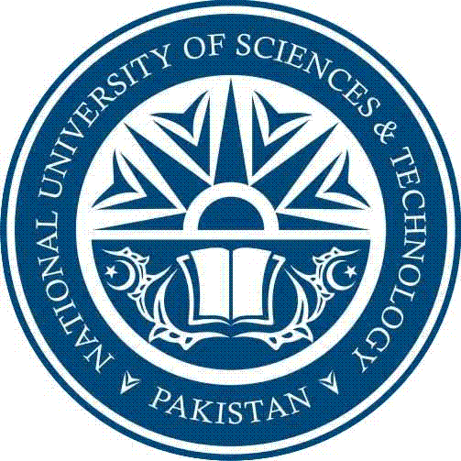

MCS-NUST

TO WHOM IT MAY CONCERN

Subject: Issue of visit permission to students

Military College of Signals (MCS), a constituent Campus of National University of Sciences and Technology (NUST), is dedicated to advancing knowledge and educating students in science, and technology. Here the fundamental purpose is to challenge students to realize their highest potential.
Every year our students are assigned challenging projects to apply their theoretical knowledge in order to explore, invent, and create logical solutions to problems. To allow them to have an impression of the professional environment, they are motivated to seek projects from the organizations.

It is requested that following students be allowed to visit your organization for academic purposes.

Name of Students: ____________________________________________
Organization Name: ________________________________
Purpose of Visit: ________________________________
Date of Visit: ________________________________

____________________ __________________
Signature of Instructor Signature of HoD

